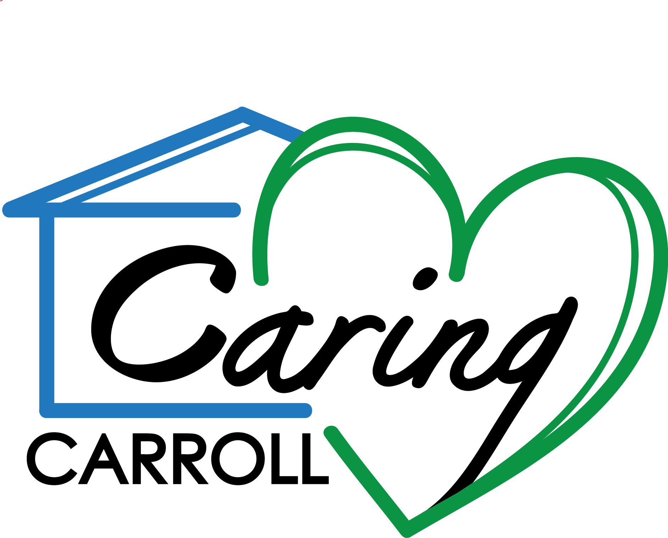

CARING CARROLL

2005
The Partnership for a Healthier Carroll County founded Faith in Action Carroll County Neighbors Helping Neighbors
Robert Wood Johnson
Foundation Grant

Church
Temple
Service Organization
Health Agency
Caring Carroll Board of Directors/Coalition

CARING CARROLL, INC.

Church
Church

Church

Caring Carroll Volunteers

THE FOUNDATION

Program Staff
(Coordinator & OfficeVolunteers)
2008

2007 Grant Period Ended

